Chapter 3
Number Systems

3.1 a. (BL 2-) Each digit is one power of 6 increased from the previous digits. Therefore, starting from the right, the digits represent 1, 6, 36, 216, and 1296.

b. (BL 2-) The decimal equivalent for 24531₆ is 2 × 1296 + 4 × 216 + 5 × 36 + 3 × 6 + 1 = 3655.

3.2 (BL 1+) In base-16, the digits from right to left have the power 1, 16, 256, 4096. In base-2, these are equivalent to 2⁰, 2⁴, 2⁸, and 2¹², so they are the 0th, 4th, 8th, and 12th digits.

3.3 a. (BL 2-) 4E₁₆ = 4 × 16 + 14 = 78

b. (BL 2-) 3D7₁₆ = 3 × 256 + 13 × 16 + 7 = 983

c. (BL 2-) 3D70₁₆ = 16 × 983 = 15728. The same result will, of course, be obtained from taking 3 × 4096 + 13 × 256 + 7 × 16.

3.4 (BL 2-) The decimal range for an 18-bit word is 0 — 2¹⁸ -1 = 0— 262143 (256K)

3.5 (BL 2) The easiest way to solve this problem is to use the approximation 2¹⁰ ≈ 1000, and the fact that 2^{A} × 2^{B} = 2^{A+B}. From this, 1,000,000 is approximately 2¹⁰ × 2¹⁰, or 20 bits, and 4,000,000 is approximately 2²⁰ × 4, or 22 bits. Therefore, the representation of 3,175,000 will require 22 bits, or 3 bytes.

3.6 a. (BL 2-)

0 1 2 3 4 5 6 7 8 9 A B
0 0 1 2 3 4 5 6 7 8 9 A B
1 1 2 3 4 5 6 7 8 9 A B 10
2 2 3 4 5 6 7 8 9 A B 10 11
3 3 4 5 6 7 8 9 A B 10 11 12
4 4 5 6 7 8 9 A B 10 11 12 13 ADDITION
5 5 6 7 8 9 A B 10 11 12 13 14
6 6 7 8 9 A B 10 11 12 13 14 15
7 7 8 9 A B 10 11 12 13 14 15 16
8 8 9 A B 10 11 12 13 14 15 16 17
9 9 A B 10 11 12 13 14 15 16 17 18
A A B 10 11 12 13 14 15 16 17 18 19
B B 10 11 12 13 14 15 16 17 18 19 1A

0 1 2 3 4 5 6 7 8 9 A B
0 0 0 0 0 0 0 0 0 0 0 0 0
1 0 1 2 3 4 5 6 7 8 9 A B
2 0 2 4 6 8 A 10 12 14 16 18 1A
3 0 3 6 9 10 13 16 19 20 23 26 29
4 0 4 8 10 14 18 20 24 28 30 34 38 MULTIPLY
5 0 5 A 13 18 21 26 2B 34 39 42 47
6 0 6 10 16 20 26 30 36 40 46 50 56
7 0 7 12 19 24 2B 36 41 48 53 5A 65
8 0 8 14 20 28 34 40 48 54 60 68 74
9 0 9 16 23 30 39 46 53 60 69 76 83
A 0 A 18 26 34 42 50 5A 68 76 84 92
B 0 B 1A 29 38 47 56 65 74 83 92 A1

b. (BL 2)

25A84
+70396
9625A

2A6
XB1
2A6
2776
27A46

3.7 a. (BL 2-)

0 1 2 3 4 5 6 7 8 9 A B C D E F
0 0 0 0 0 0 0 0 0 0 0 0 0 0 0 0 0
1 0 1 2 3 4 5 6 7 8 9 A B C D E F
2 0 2 4 6 8 A C E 10 12 14 16 18 1A 1C 1E
3 0 3 6 9 C F 12 15 18 1B 1E 21 24 27 2A 2D
4 0 4 8 C 10 14 18 1C 20 24 28 2C 30 34 38 3C MULTIPLY
5 0 5 A F 14 19 1E 23 28 2D 32 37 3C 41 46 4B
6 0 6 C 12 18 1E 24 2A 30 36 3C 42 48 4E 54 5A
7 0 7 E 15 1C 23 2A 31 38 3F 46 4D 54 5B 62 69
8 0 8 10 18 20 28 30 38 40 48 50 58 60 68 70 78
9 0 9 12 1B 24 2D 36 3F 48 51 5A 63 6C 75 7E 87
A 0 A 14 1E 28 32 3C 46 50 5A 64 6E 78 82 8C 96
B 0 B 16 21 2C 37 42 4D 58 63 6E 79 84 8F 9A A5
C 0 C 18 24 30 3C 48 54 60 6C 78 84 90 9C A8 B4
D 0 D 1A 27 34 41 4E 5B 68 75 82 8F 9C A9 B6 C3
E 0 E 1C 2A 38 46 54 62 70 7E 8C 9A A8 B6 C4 D2
F 0 F 1E 2D 3C 4B 5A 69 78 87 96 A5 B4 C3 D2 E1

b. (BL 2) 2AB3
+35DC
608F

c. (BL 2) 1FF9
+F7
20F0

d. (BL 2) 2E26
x 4A
1CD7C
B898
D56FC

3.8 a & e. (BL 2)
101101101 = 16D₁₆
+10011011 = 9B₁₆
1000001000 = 208₁₆

b & e. (BL 2)
110111111 = 1BF₁₆
+1 = 1₁₆
111000000 = 1C0₁₆

c & e. (BL 2)
11010011= D3₁₆
+10001010 = 8A₁₆
101011101 = 15D₁₆

d & e. (BL 2)
1101 = D₁₆
1010 = A₁₆
111 = 7₁₆
+101 = 5₁₆
100011 = 23₁₆

3.9 a. (BL2) 1101
X 101
1101
11010
1000001

B. (BL2) 11011
X1011
11011
11011
110110
100101001

3.10 a. (BL2+)
1101100
110 )1010001001
110
1000
110
1001
110
110
110
01

B. (BL2+)
10001011
1011 )11000000000
1011
10000
1011
10100
1011
10010
1011
111

3.11 (BL2-) The powers of digits in 8 are 1, 8, 64, 512, 4096. Therefore,
6026 - 1 × 4096 = 1930 - 3 × 512 = 394 - 6 × 64 = 10 - 1 × 8 = 2.
The solution is 13612₈

3.12 (BL2-) The powers of digits in hexadecimal are 1, 16, 256, 4096. Therefore,
6026 - 1 × 4096 = 1930 - 7 × 256 = 138 - 8 × 16 = 10.
The solution is 178A₁₆

3.13 (all BL2-)
a. 12)13750 (10 = A
12) 1145 ( 5 7B5A₁₂
12) 95 (11 = B
7

b. 16) 6026 (10 = A
16) 376 (8 178A₁₆
16) 23 (7
1

c. 5) 3175 (0
5) 635 (0
5) 127 (2 100200₅
5) 25 (0
5) 5 (0
1

3.14 (all BL2-)
a. 2)4098 (0
2)2049 (1
2)1024 (0
2) 512 (0
2) 256 (0 1 0 0 0 0 0 0 0 0 0 0 1 0
2) 128 (0
2) 64 (0 4096 + 2 = 4098
2) 32 (0
2) 16 (0
2) 8 (0
2) 4 (0
2) 2 (0
1
b. 2)71269 (1
2)35634 (0
2)17817 (1
2) 8908 (0
2) 4454 (0 1 0 0 0 1 0 1 1 0 0 1 1 0 0 1 0 1 2) 2227 (1 65536 +
2) 1113 (1 4096 +
2) 556 (0 1024+512+
2) 278 (0 64+32 + 4 + 1 = 2) 139 (1
2) 69 (1 71269
2) 34 (0
2) 17 (1
2) 8 (0
2) 4 (0
2) 2 (0
1

c. 2) 37 (1
2) 18 (0 1 0 0 1 0 1
2) 9 (1
2) 4 (0 32 + 4 + 1 = 37
2) 2 (0
1

3.15 a. (BL2-) Converting 1100010100100001 to decimal. Working from left to right:

1×2=2+1=3+0=3×2=6+0=6×2=12+0=12×2=24+0=24×2=48+1=49×2=98+0=98×2=196+1=197×2=394+0=394×2=788+0=788×2=1576+1=1577×2=3154+0=3154×2=6308+0=6308×2=12616+0=12616×2=25232+0=25232×2=50464+1= 50465

b. (BL2) Converting C521₁₆ to decimal

12×16=192+5=197×16=3152+2=3154×16=50464+1= 50465

Of course, the student should notice that the result is the same, and that C521 converts to the binary value in part a.

c. (BL2) Converting 3ADF₁₆ to decimal,

3×16=48+10=58×16=928+13=941×16=15056+15= 15071

d. (BL2) Converting 24556₇ to decimal,

2×7=14+4=18×7=126+5=131×7=917+5=922×7=6454+6= 6460

3.16 a. (BL1+) 101 1011 1011 1010
5 B B A

b. (BL1+) 1111 1111 1111 0001
F F F 1

c. (BL1+) 1 1111 1110 1111
1 F E F

d. (BL1+) 110 0011 0001 1001
6 3 1 9

3.17 (all BL1+)
a. 4 F 6 A
100 1111 0110 1010

b. 9 9 0 2
1001 1001 0000 0010

c. A 3 A B
1010 0011 1010 1011

d. 1 0 0 0
1 0000 0000 0000

3.18 (BL3) A good choice would be 9. Each pair of digits in base 3 would correspond to a single digit in base 9.

22 01 12 10 base 3 =
8 1 5 3 base 9

3.19 a. (BL3) Each pair of digits in base 4 represents a single hexadecimal digit:

13 02 30 31 base 4 =
7 2 12 13
7 2 C D base 16

Converting each to decimal, using the multiplication technique,

1×4=4+3=7×4=28+0=28×4=112+2=114×4=456+3=459×4=1836+0=1836 ×4= 7344+3=7347×4=29388+1 = 29389

7×16=112+2=114×16=1824+12=1836×16=29376+13 = 29389

b. (BL3) 9 B 6 2₁₆ → 1001 1011 0110 0010
21 23 12 02₄ → 1001 1011 0110 0010

3.20 (BL3) This conversion is performed using decimal as an intermediary number base. Using the power method for both conversions,

210102₃ = 2 + 9 + 81 + 2 × 243 = 578₁₀.
578₁₀ = 512 + 64 + 2 × 1 = 1102₈.

3.21 (BL3) This conversion is perfomed using binary as an intermediary.

27745₈ = 010 111 111 100 101. Regrouping yields the hexadecimal result:
0010 1111 1110 0101 = 2FE5₁₆.

3.22 (BL3) This is a programming problem, with a number of different solutions. The easiest approach is to accept digits from the keyboard as characters, one at a time. The result is initialized to zero. As characters are entered, each character is checked for validity and converted to an integer. Using the multiplier method, the previous result is multiplied by 8, and the new digit added to the result to form the new result. The process stops when the input character is a space or carriage return.

3.23 (BL3) This is a programming problem, with a number of different solutions. The division method can be used here. The number is entered as an integer., then divided by 16, using integer division to get the next dividend and a MOD function to get the remainder. Each remainder value is converted to its hexadecimal equivalent, and saved as a character. The process continues in a loop until the quotient is 0. The output is printed, starting from the last remainder.

3.24 (BL3) This is a programming problem, with a number of different solutions. Arguably, the easiest solution is to perform both conversions with base 10 as an intermediary. One approach to direct conversion is to build a pair of tables that match integer values from 0 to 15 with their corresponding hexadecimal and binary text strings. Then, to convert from binary to hexadecimal, the program takes the binary input as characters, collects the characters into groups of four, calculates the value for each group, looks up the hexadecimal equivalent and prints it. A crucial point is that the binary digits must be grouped from least significant bit to most significant, which requires that all of the data must be entered before grouping can take place. Conversion in the other direction is easier, since each hexadecimal digit can be converted to its binary equivalent directly from the tables.

3.25 (all BL2)
a. 0.6640625
X16
10 .6250000 The solution is 0.AA₁₆
X16
10 .0000000

b. 0.3333
X16
5 .3328
X16
5 .3248 The solution is 0.5553₁₆ ...
X16
5 .1968
X16
3 .1488

c. 69/256 = (64 + 4 + 1)/256 = 1/4 + 1/16 + 1/256 = .01010001 = 0.51₁₆

3.26 (all BL2)
a. 0.10010012 = 1/2 + 1/16 + 1/128 = (64 + 8 + 1) / 128 = .0.5703₁₀

b. 0.3A2₁₆ = 3/16 + 10/256 + 2/4096 = (768 + 160 + 2) / 4096 = 0.2270₁₀

c. 0.2A1₁₂ = 2/12 + 10/144 + 1/1728 = (288 + 120 + 1) /1728 = 0.2366₁₀

3.27 (all BL2)
a. 27.625 = (16 + 8 + 2 + 1) . 625. Either recognize that .625 = 5/8 or multiply:

.625
X2
1.250
X2 The result is 11011.1010₂ = 1B.A₁₆
0 .50
X2
1 .00

b. 4192.37761 = (4096 + 64 + 32).37761

.37761
X2
0 .75522
X2
1 .51044
X2
1 .02088 The solution is 1000001100000.01100000₂ = 1060.60₁₆
X2
0 .04176
X2
0 .08352
X2
0 .16704
X2
0 .33408
X2
0 .66816

3.28 a. 1100101.1 = (64 + 32 +4 + 1). (1/2) = 101.5

b. 1110010.11 = (64 + 32 + 16 + 2). (1/2 + 3/4) = 114.75

c. 11100101.1 = (128 + 64 + 32 + 4 + 1).(1/2) = 229.5.

Since this number is the same as the one in part b with the binary point shifted one to the right, you would expect the value to be exactly twice that of the value in b, which it is.

3.29 (BL1+)
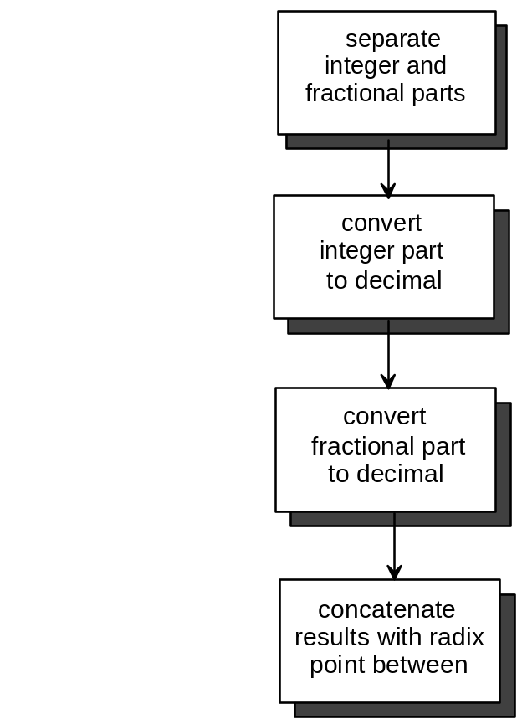
3.30 (BL3) This is a programming problem. The key to the solution is breaking the mixed number into integer and fractional parts, then using the techniques discussed in the text for handling each part. A well-designed program would have a separate subroutine or function for each of the four conversions.

